**ACTIVITY 6**

**NAME : Shalini devi.M COURSE: MOBILE COMPUTING**

**REG NO : 192421351 COURSE CODE: ITA0302**

6. Use Figma to simulate a handoff scenario in a mobile network and visualize the process.

**Aim:**

To simulate a handoff scenario in a mobile network and visualize the process using

Figma.

**Procedure:**

1. Open Figma

2. Create a new file

3. Select the Frames

4. Fill in the content that is required for presentation

5. Design Visual Elements

6. Make it Interactive

7. Add Annotations and Explanations

8. Incorporate Multimedia

9. Storyboard Animation

10. Review and edit the Prototype

11. Save and Share

Design:

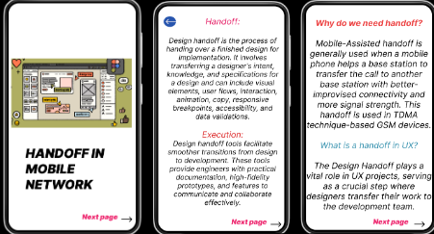

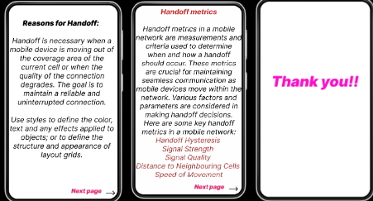

**Prototype:**

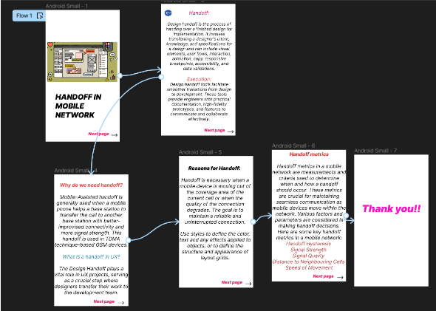

**Result:**

Hence the simulated a handoff scenario in a mobile network and visualized the process using

Figma.